Here are five engaging social media post ideas for SynthMind Creative, each designed to stop the scroll and drive action

**Post 1: The "Aha!" Moment**

Call to Action: "Click the link in our bio to schedule a free 15-minute Brand Genesis Scan!"

**Post 2: The Data-Driven Teaser**

Call to Action: "DM us the word 'DATA' for a free market insight report."

**Post 3: The "Before & After" Carousel**

Call to Action: "Tap the link in our bio to see our portfolio of startup success stories!"

**Post 4: The Interactive Question**

Call to Action: "Comment with your letter below!" (The PS also creates a secondary, organic CTA for DMs).

**Post 5: The Visionary Manifesto**

Call to Action: "Tap 'Learn More' to discover our startup-focused packages!" (Optimized for use as a paid ad with a direct link).

**B. SOCIAL MEDIA POST**

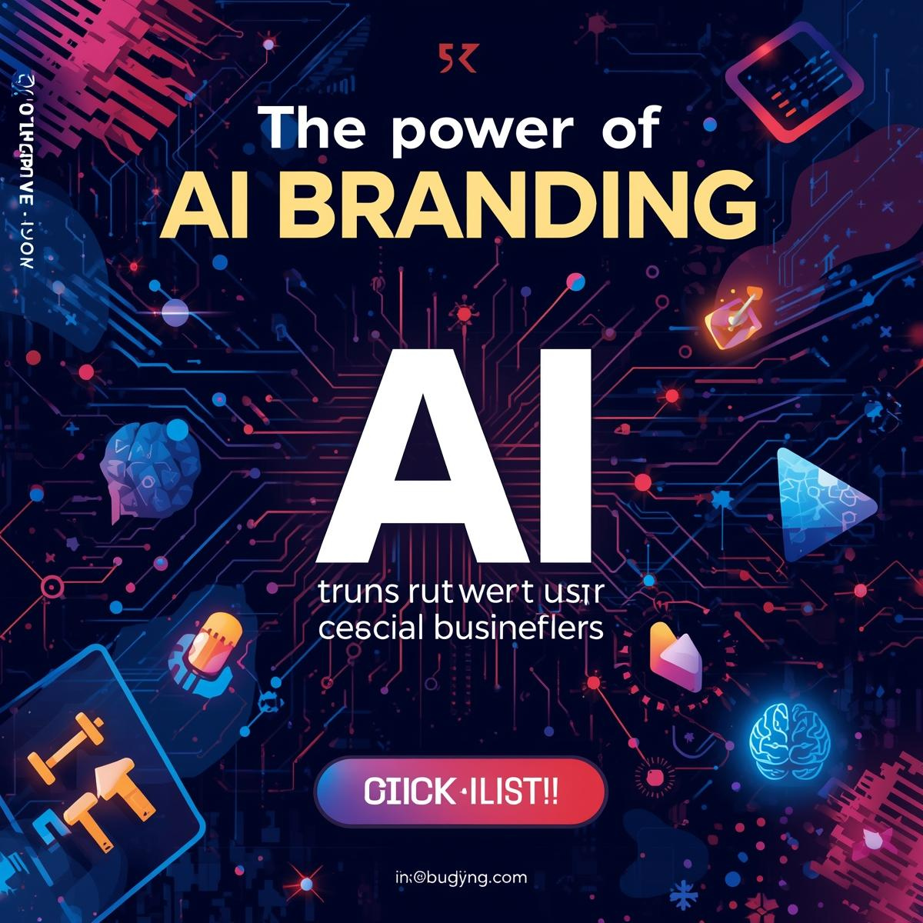

**C. MARKETING COPY**

Of course. Here is a blog post crafted to be published on the SynthMind Creative website or guest posts on startup-focused platforms.

Beyond the Logo: Why AI-Powered Branding is Your Startup's Unfair Advantage

Meta Description: Is your brand built on guesswork or data? Discover how AI-powered branding services use data-driven insights to create resonant, agile, and dominant brands that leave the competition behind.

If you’re a founder or business leader, you’ve felt the pressure. The market moves faster every day. Consumer attention is the world's most scarce resource. And standing out isn't just a goal—it's a matter of survival.

In this landscape, relying on traditional, intuition-based branding is like using a paper map in the age of GPS. It might eventually get you there, but you’ll waste precious time and fuel navigating dead ends. The businesses that will define the next decade aren't just using technology in their products; they're infusing it into their very identity from day one.

Welcome to the era of AI-powered branding. This isn't about robots replacing designers; it's about leveraging artificial intelligence as a co-pilot to make smarter, faster, and more impactful branding decisions. Here’s why it’s no longer a luxury, but a critical component of a competitive strategy.

**1. Move at the Speed of the Market**

The traditional branding process can take months—from market research and mood boards to countless revisions. In that time, a competitor can emerge, or a cultural trend can shift.

The AI Advantage: AI compresses this timeline dramatically. An AI engine can analyze global design trends, competitor landscapes, and audience sentiment in hours, not weeks. It can generate hundreds of name ideas, logo concepts, and color palettes for human creatives to refine. This means you can go from a blank slate to a market-ready brand identity in a fraction of the time, allowing you to launch, iterate, and pivot with agility.

**2. Replace Guesswork with Data-Driven Insight**

Ask ten people what makes a brand "resonate," and you'll get ten different answers. Traditional branding often relies on the taste and experience of a small team. While valuable, this is inherently limited.

The AI Advantage: AI operates on a foundation of vast data. It can process millions of data points from social media, search trends, and consumer behavior to answer critical questions with precision:

* What visual aesthetics are engaging my target demographic *right now*?

* What emotional triggers drive their purchasing decisions?

* What gaps exist in my competitors' branding that I can exploit?

This moves the conversation from "We think this looks good" to The data shows this will perform.

**3. Build a Deeply Resonant Brand Narrative**

Your brand story isn't what you tell people; it’s what they believe about you based on the signals you send. Crafting a narrative that feels authentic and compelling is hard.

**The AI Advantage:** Natural Language Processing (NLP) models can analyze your company's mission, values, and target audience to help craft a core narrative and messaging framework. It can ensure your tone of voice is consistent across all touchpoints, from your website copy to your customer support chats, building a cohesive and trustworthy brand experience.

**4. Achieve Unprecedented Personalization at Scale**

The future of marketing is hyper-personalization. Customers expect brands to understand their individual needs.

**The AI Advantage:** An AI-powered brand system can dynamically personalize marketing assets. Imagine serving slightly different versions of your homepage, ads, or email campaigns to different audience segments, with each version optimized by AI for maximum engagement. This level of personalization, once only available to tech giants, is now accessible to agile startups using the right tools.

**5. Future-Proof Your Brand**

A static brand is a dying brand. The most successful modern brands are dynamic systems that can evolve.

The AI Advantage: AI provides continuous monitoring. It can track the performance of your brand assets in real-time and alert you to shifting perceptions or emerging negative sentiment. It can also A/B test messaging and visuals autonomously, ensuring your brand is always optimizing and improving, rather than waiting for an annual (and outdated) brand audit.

The Human-AI Synergy: The Best of Both Worlds

Let’s be clear: AI doesn't replace human creativity, intuition, and strategic vision. It amplifies it.

Think of it as a partnership. The AI is the ultimate research assistant, data analyst, and rapid prototype generator. The human brand strategist is the conductor—interpreting the data, making the nuanced creative leaps, understanding cultural context, and ensuring the final output has that essential spark of soul and authenticity.

This synergy creates a powerful feedback loop: human creativity guides the AI, and AI-powered insights inspire human creativity.

**Conclusion: Don't Get Left Behind**

The competitive landscape is being redrawn. The businesses that will thrive are those that embrace intelligent tools to work smarter and move faster. AI-powered branding isn't a fleeting trend; it's the new baseline for building a relevant, resilient, and dominant brand.

Your brand is your most valuable asset. Isn't it time you used the most advanced tools available to build it?

Is your brand built for the future?

At SynthMind Creative, we combine our proprietary AI engine with expert human strategists to deliver brands that are data-smart and human-brilliant. Schedule a free, no-obligation Brand Genesis Scan with us today and see what your brand could become.